Test Result Report

**Calculator_v1.0 / M-ST1-239-21 project**

**Period: Apr 5th - Apr 8th, 2021**

1. **TEST TEAM**

|  |  |  |
| --- | --- | --- |
| **Employee name** | **Job title** | **Project role** |
| Veronica Nasevich | Junior QA Engineer | Functional and non-functional testing |

1. **TESTING TIME**

|  |  |  |  |
| --- | --- | --- | --- |
| **Full name** | **Date** | **Description** | **Duration (hours)** |
| Veronica Nasevich | 05.04.2021 | Test-cases creation | 8 |
| Veronica Nasevich | 06.04.2021 | Regression test-suites creation | 2 |
| Veronica Nasevich | 06.04.2021 | Creation of test runs for different environment: Win 7, Win 10x32, Win 10x64 | 1 |
| Veronica Nasevich | 07.04.2021 | Non-functional testing | 2 |
| Veronica Nasevich | 07.04.2021 | Functional testing | 4 |
| Veronica Nasevich | 08.04.2021 | Bug report creation | 4 |

1. **BUILDS RELEASED**

The first version of a build for the Сalculator application: calc_v1.0.

1. **TESTING PROCESS DESCRIPTION**

Test environment: OC Windows 10 Pro build 1809 64-bit.

Test level: Regression testing.

Testing types used: Functional, GUI, Localization testing.

All test scenarios were created based on customer requirements (see Requirements_Calc_v1.3.docx uploaded to project Google Drive folder) using black-box testing techniques.

All tests are performed manually. The result is as follows:

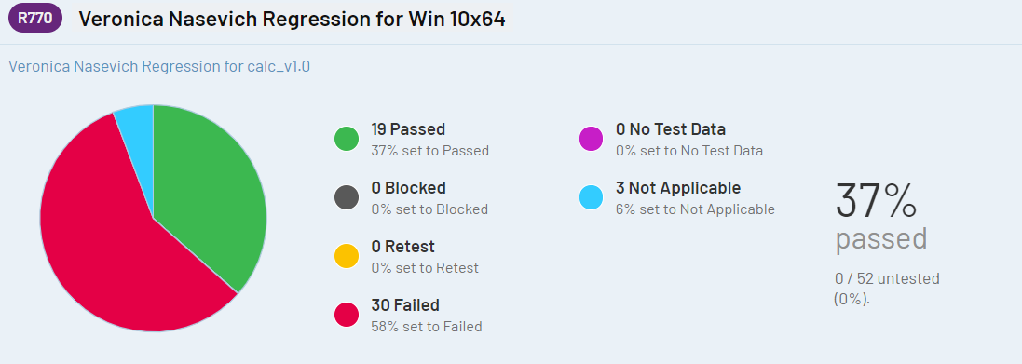

Execution details see at: [Test Rail](http://178.124.206.46:8000/index.php?/runs/view/770&group_by=cases:section_id&group_order=asc) test plan and test statistic section of this document.

1. **SUMMARY**

For the reporting week tasks done:

1. Test-cases writing (52 out of 52):

* Getting started module - 1
* GUI module - 17
* Non-functional module - 3
* Functional module - 31

Test status: **Red**

Test analysis: There are 30 bugs found. Smoke test is unpassed. 3 tests have “not applicable” status, as critical path functions have not been fully implemented yet. Both positive and negative tests were failed. The application has many problems with GUI as well as functionality. Product quality is low.

Plans for next week: run regression testing under other OCs (Win 7, Win 10x32), bug reports creation, receive build 1.1, start test execution.

**6. TEST STATUS**

* Requirements

Requirement #13 is unverifiable, all the other requirements were covered by 1 test-case min.

* Test-case creation

**52 test-cases** were created in total: **smoke** priority - **7**, **critical path** priority - **37**, **extended** priority - **8**.

* Test execution:

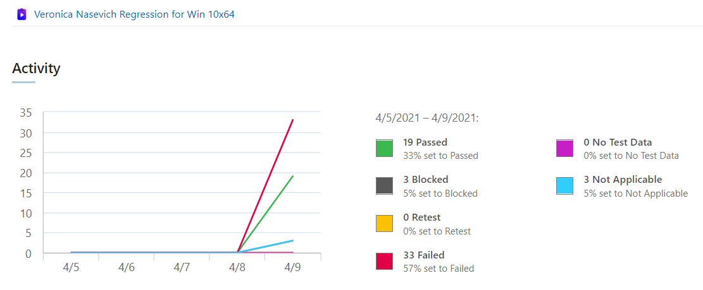

Successfully passed TC by priority,%:

|  |  |  |
| --- | --- | --- |
|  | **Passed, %** | **Failed, %** |
| **Smoke** | 28 | 72 |
| **Critical Path\*** | 43 | 49 |
| **Extended** | 12 | 88 |

*8% of cricitical path TC are not applicable

* Bugs:

**30 bugs** found in total.

Bugs found by priority:

ASAP: 12/30

High: 4/30

Normal: 7/30

Low: 7/30

Bugs found by severity:

Critical: 12/30

Major: 2/30

Medium: 5/30

Minor: 11/30

**7. RECOMMENDATIONS AND CONCLUSIONS**

Due to the circumstance that the vast majority of problems found are related to mathematical operations, first of all I would recommend to pay attention to fixing the basic functionality of Simple mode, then to fix all issues related to Scientific mode and then to focus on GUI issues.